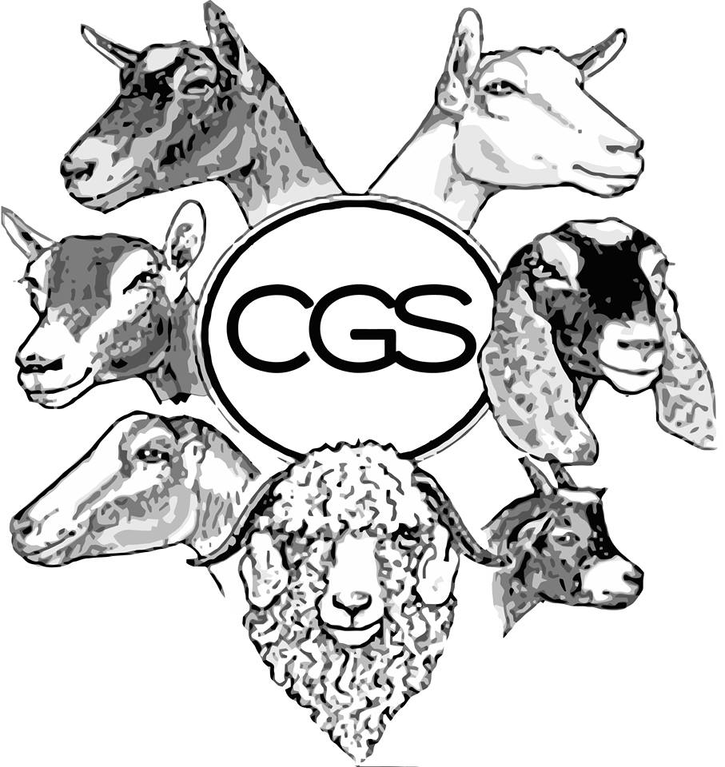

CANADIAN GOAT SOCIETY

CLASSIFICATION MANUAL **2019**

Table of Contents

1. Preface 3

2. Overview of Dairy Goat Classification 4

3. Preparing for Classification: 5

4. Animals to be classified 5

5. Application for a Classification Visit 6

6. Type classification enrollment program fees 7

7. Biosecurity Policy for Classifiers 8

8. Privacy Policy and Data Retention for Classification 8

9. Complaints 8

10. Breed Standards 9

Alpine 9

LaMancha 10

Nubian 11

Oberhasli 12

Saanen 13

Toggenburg 14

Nigerian Dwarf 15

11. “True Type” is the Standard 16

Breed Standards 16

12. Breakdown of Traits 17

Rump (10% of final score) 17

**Loin Strength (22% of rump score)** 18

**Thurl Placement (Research)** 18

Rump Defects 19

Mammary System (42% of final score) 19

Mammary System Defects: 23

Dairy Strength (20% of final score) 24

Dairy Strength Defects 27

Feet & Legs (28% of final score) 27

Feet and Legs defects 30

Genitalia (Males only) 31

**Canadian Goat Society Classification Manual**

# 

# Preface

This booklet is designed to be a reference for the Canadian Goat Society’s classification Program. The information is derived from the minutes and feedback from conferences, workshops and meetings of the classification committee over the past several years with the assistance of CGS Classifiers, CGS Breeders, Holstein Canada, Ontario Goat, and Brian Sullivan of CSSI. The Type Classification Program is a very important breed improvement tool for the dairy Canadian goat industry.

Illustrations by Angela K. Beltane © 1999

# Overview of Dairy Goat Classification

###### What is classification?

Type Classification compares a dairy goat to an ideal. The current system evaluates 25 different individual traits that are separated in 4 categories for Does; Rump (10%), Mammary System (42%), Dairy Strength (22%) and Feet & Legs (26%) and 3 categories for Bucks; Rump (20%), Dairy Strength (40%) and Feet & Legs (40%). A final score of 90 and above is Excellent (EX), 85-89 is Very Good (VG), 80-84 Good Plus (GP), 75-79 is Good (G) and 70-74 is Fair (F). Our Non-Selective program requires that all first fresheners on the farm be presented for classification. This enables classification data to be used in Genetic Evaluations ([www.goatgenetics.ca](http://www.goatgenetics.ca)).

Three of the most frequent reasons animals are removed from the herd include: reproductive problems, feet and leg problems, and mastitis/high somatic cell count. Conformation appraisal in first lactation offers herd owners an early indication of where an animal has structural weaknesses that will translate into diminished functionality later in life. Increasing longevity enables goats to achieve higher profitability per day of life.

###### Why Classify?

* It is an important herd management tool which helps owners make improvements to the functional conformation of their dairy herds, with the objective of selecting for the goat’s natural ability to produce higher volumes of milk over longer lifetimes.
* In accordance with breed goals, the classification system aims to select goats with optimal workability: that are easy to work with, more resistant to breakdown or disease, trouble-free, and lower maintenance.
* The objective is to select for goats that can perform at higher levels with greater ease.
* Classification is considered a small investment that makes a lot of economic sense for a successful dairy enterprise.
* Classifying allows the herd owner to benchmark their goats in comparison to the national population and trends.

###### Benefits to Classifying your Animals:

* Early culling tool that identifies problem animals
* Insight into possible management changes
* Consultation with an objective/unbiased trained expert who sees several farms across Canada
* Mating & selection tool (www.goatgenetics.ca)
* Select best does in herd to develop
* Select optimal sire to mate to each doe

# Preparing for Classification:

In order to fully benefit from a herd classification and to be as efficient as possible, follow these few tips:

About two weeks prior to classification

CGS office will notify you of the upcoming classification. For each doe to classify, you will need to have the following information available:

* + Lactation number (how many times the doe has had normal lactations. Please see section “Lactations Started Abnormally” for added clarity on what is not considered a normal lactation)
  + Kidding date, exact date is required
* **You will need the original registration certificates for all animals being classified in order to get official recognition**. Ensure that all tattoos match exactly the registration certificate before classification. Registration cerficates and information on each doe should be readily availble on classification day.

###### A few days prior classification

* It is not necessary to show clip for classification. It is desirable to make sure that the animal’s feet have been trimmed and excessive hair has been clipped off.
* If there are any changes from the form submitted to the office, let the classifier know and gather all of the correct information.

###### The day before or day of classification (prior to the arrival of the classifier)

* Prepare an area for classification that is well lit and has a firm, dry surface and is large enough to have a handler move the animals around freely.
* Prepare an area to set the paperwork, checklist and registration papers.
* Prepare a space (i.e. a table) to put the laptop/printer with access to an electrical outlet if possible.
* Have all eligible animals ready and easily accessible nearby is instrumental to a smooth and timely classification. A few extra handlers to help having the animals available to score as soon as the previous one is done is preferable. This is an excellent opportunity to connect with your local 4H club!

Avoid extreme uddering of does. Does can be classified when they are milked out or full. Overuddering can be detrimental the scoring.

###### Registration Certificates

The owner must provide to the classifier: birth date, kidding date, lactation number, previous classification scores (if applicable), and other information as necessary.

The classifier will check identity of every goat by comparing the tattoo and registration certificate. If there is any missing information or incorrect tattoos, the animal will be classified and a report made to the office to handle the situation.

# Animals to be classified

Regardless of ownership (sole or joint), all eligible animals resident in the herd being classified, are to be classified.

**All registered (and pending registration) first lactation animals must be classified**. Each milking female in the herd that is on its 1st (first) lactation and is registered/or registerable must be presented for classification.

Unregistered First lactation animals (will be unofficial) and any second and later lactation registered does may be classified at the owner’s option. Bucks are to be classified at the option of the owner. Owners are encouraged to classify all animals to assist in genetic evaluations and herd management.

Animals that were previously classified can be presented again for a possible raise in score (scores should not be lowered).

Horned goats are eligible for classification.

Any doe that is under 24 months of age that has never freshened and any buck under 12 months of age are considered juniors. Junior does and bucks and dry does may be presented for classification. Their score is unofficial (not recorded by CGS) and can be used for herd management purposes only.

###### Owner has Animals in other Herds

When animals owned by one person are kept in two or more herds, these animals shall be classified at the same time as the owner's herd. Unless the herd in which the animals are resident is being classified in the same round.

###### Foreign Animal

Animals imported from the United States that do not have a Canadian registration certificate will be classified if the American animal has been transferred to the Canadian owner on the American certificate and will become official upon proof of transfer to Canadian certificate.

###### All eligible animals must be presented

A Classification Application form shall be completed and signed by the herd owner indicating that all eligible animals are been presented for classification. The classifier will report to the office any herd that he/she feels has not presented all eligible animals.

###### Classification order within the herd

The owner may present the animals in any order he/she wishes for classification.

###### Lactations Started Abnormally

First lactation does which have initiated production by:

* Aborting at three months or less: or
* Brought into milk by use of a hormone (no kidding).

These animals with abnormal lactations will not be required to be scored.

###### Milk-Out

A classifier can request a milk-out on any doe in case of doubt. Does are to be milked in the presence of classifier.

# Application for a Classification Visit

Members complete an application for classification and return it to the office with the appropriate fees. A late fee will apply if the application is not received by the office before the application deadline.

###### Field operations

For practical purposes, a herd is defined as all animals housed in one location. (Milk out on animals prepared for classification is at the discretion of the classifier.)

A classifier may suggest two classifiers attend a visit. The owner does not have the right to refuse. The general policy shall be one classifier per herd visit except for:

* Large herds
* Upon instruction from the office
* Classifier training or assessment by a superior

###### Place of Classification

Normally, the place of classification, whether inside or outside, is at the option of the owner, but the classifier may ask to let the animal go free so that he/she can see the animal in its natural state. Classifiers may request the animal be held in a confined area. Animals should be viewed walking as much as possible.

###### Scheduling by Classifiers

The Classification Committee will determine the assignment of and scheduling of Classifiers, pending approval of the Board of Directors. Classifiers are assigned to areas in rotation within the time and budget allowances. The classifier assigned will give the herd owner a minimum of two (2) weeks’ notice to his/her visit.

###### Application for Special Service (off schedule)

Special classification service can be available to breeders / herd owners assuming there is a classifier available and must be cost effective (see fee schedule).

###### Owner Delaying Classification Visit

The owner must take the classifier when he/she available. Classifiers are to operate on the premise that an owner is allowed one refusal. At the time of the refusal, the classifier shall inform the owner that he/she must accept a classification visit when the classifier next calls or classification service will not be provided this round.

Owners must not accept a classification visit and then attempt to reschedule it unless there is extenuating circumstances. **Owners cancelling classification services may be charged a penalty fee if doing so causes additional costs to CGS.**

# Type classification enrollment program fees

###### Regular Visit

The fees are listed in the current classification application form.

###### Special herd visit

Special herd visits must be cost effective. In order to schedule a special herd visit, contact the CGS office for pricing and availability.

###### Refunds

Payment of applicable Site fee plus applicable taxes is due with application. This fee is not refundable for cancellation by member.

###### Penalty Fee

Late applications are subject to a fee as per the most current CGS fee schedule. Service will be provided for late application only if the classifier can adjust the schedule to fit the herd in.

# Biosecurity Policy for Classifiers

Biosecurity is everyone’s responsibility. Good biosecurity protects businesses and jobs in primary production and supporting industry. Classifiers adhere to strict biosecurity measures when providing the classification service to help minimize the risk of spreading infectious diseases.

###### Footwear and Hands

Classifiers wear clean rubber boots or disposable footwear at every farm visit. Upon departure from the farm, the classifier completely washes and disinfects his/her hands and rubber boots or removes disposable footwear. In addition, classifiers walk through any footbath at entry to the barn.

###### Clothing

Classifiers start each day with freshly-washed clothes. In addition, the clothes are changed if they become soiled during the day. When temperatures require additional clothing in winter, fall or spring, jackets are worn on the outer-most layer. Similarly, classifiers start each day with a freshly-washed jacket and change it during the day if it becomes soiled.

Please advise your classifier of any additional biosecurity measures in place on your farm before they arrive. Classifiers will make every reasonable effort to follow these procedures.

# Privacy Policy and Data Retention for Classification

Classification scores will be collected, used, or disclosed with the knowledge and consent of the owner. The final results of the animals classified will be published on CGS website and/or Quarterly and will also be used for genetic evaluation.

# Complaints

All complaints must be in writing and sent to the CGS office within 21 days of occurrence.

# Breed Standards

### Alpine

###### 

The Alpine dairy goat is also referred to as the French Alpine and registration papers for this dairy goat use both designations and they are synonymous. The Alpine dairy goat is a medium to large size animal, alertly graceful, and the only breed with uprights ears that offers all colours and combination of colours giving them distinction and individuality. These are hardy, adaptable animals that thrive in any climate while maintaining good health and excellent production. The hair is medium to short. The face is straight or dished. A Roman nose, Toggenburg colour and markings, or all-white is discriminated against. The Alpine is described by using the following terms:

COU BLANC: white neck, with white front quarters and black hindquarters with black or grey markings on head.

COU CLAIR: light neck, with front quarters are tan, saffron, off-white, or shading to grey with black hindquarters.

COU NOIR: black neck, with front quarters and white hindquarter.

SUNDGAU: black with white markings such as underbody, facial stripes, etc.

PIED: spotted or mottled.

CHAMOISEE: brown or bay with the characteristic markings that are black face, dorsal stripe, feet and legs, and sometimes a martingale running over the withers and down to the chest. Spelling for male is chamoise.

TWO-TONE CHAMOISEE: light front quarters with brown or grey hindquarters. This is not a cou blanc or cou clair as these terms are reserved for animals with black hindquarters.

BROKEN CHAMOISEE: a solid chamoisee broken with another colour by being banded or splashed, etc.

Any variation in the above patterns broken with white should be described as a broken pattern such as broken cou blanc.

**Disqualifications**: pendulous, gopher, or elf ears, bucks that are all white in color.

### LaMancha

###### 

The LaMancha is a medium-sized breed. The face is straight. A Roman nose is a moderate-to-serious defect, depending on degree. The hair is short, fine and glossy, and may be any colour or combination of colours. There are two types of LaMancha ears; the gopher ear (not more than one inch in length with very little or no cartilage, no cartilage preferred), and the elf ear (an approximate maximum length of two inches with cartilage allowed shaping the small ear). The ends of both types of ear must be turned up or down.

Only bucks with gopher ears may be registered. Bucks with any type of ear other than the gopher ear are disqualified. One ear type has no advantage over the other for does, but does are disqualified if they have ears other than true LaMancha type.

**Disqualification**: anything other than ears as above

### Nubian

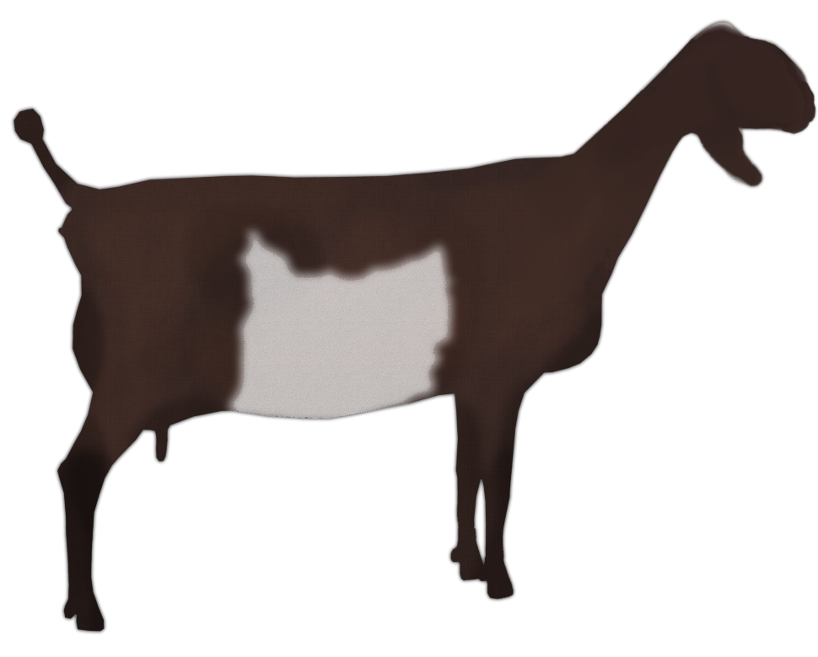

The Nubian is a relatively large, proud, and graceful dairy goat of mixed Asian, African, and European origin, known for high quality, high butterfat milk production. The head is the distinctive breed characteristic, with the facial profile between the eyes and the muzzle being strongly convex. The ears are long *(extending at least one inch (2.54 cm) beyond the muzzle when held flat along the face),* wide and pendulous. They lie close to the head at the temple and flare slightly out and well forward at the rounded tip, forming a “bell” shape. The ears are not thick, with the cartilage well defined. The hair is short, fine and glossy. Any color or colors, solid or patterned, is acceptable.

**Disqualifications**: dished face, upright, elf, or gopher ears

### Oberhasli

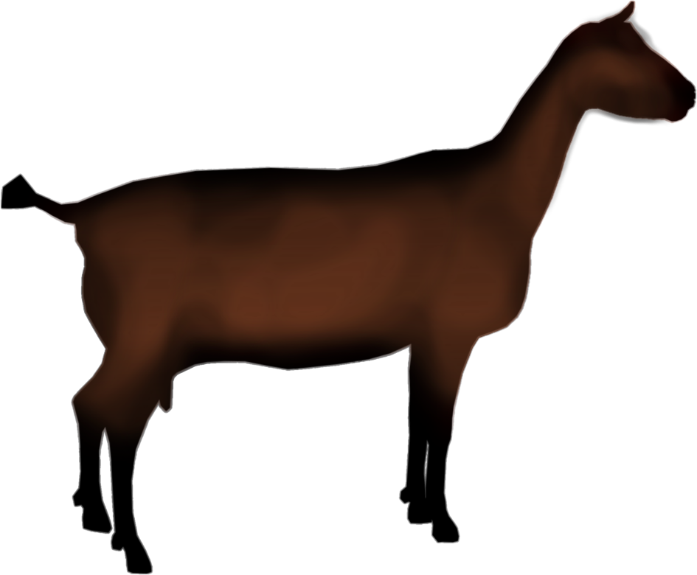

The Oberhasli is a Swiss dairy goat. This breed is of medium size, vigorous and alert in appearance. Its color is chamoisee. Does may be black but chamoisee (M.-chamoisee is preferred. Chamoisee is described as: bay ranging from light to a deep red bay with the latter most desirable. A few white hairs through the coat and about the ears are permitted. Markings are to be: two black stripes down the face from above each eye to a black muzzle; forehead nearly all black, black stripes from the base of each ear coming to a point just back of the poll and continuing along the neck and back as a dorsal stripe to the tail; a black belly and udder; black legs below the knees and hocks; ears black inside and bay outside; bucks often have more black on the head than does, black whiskers and black hair along the shoulders and lower chest with a mantle of black along the back; bucks frequently have more white hairs through the coat than does. The face is straight. Ears should be erect. A Roman nose is discriminated against.

Color must be Chamoisee with black markings such as facial stripes, forehead, dorsal stripe, martingale and belly: udder gray or black (black does are permitted but will be identified with “black” as a suffix to their registered name).

**Disqualifications**: Pendulous, gopher, or elf ears, black bucks, large white spot in hair (more than 1-1/2" in any direction), any color other than chamoisee in bucks, any color other than chamoisee or black in does.

### Saanen

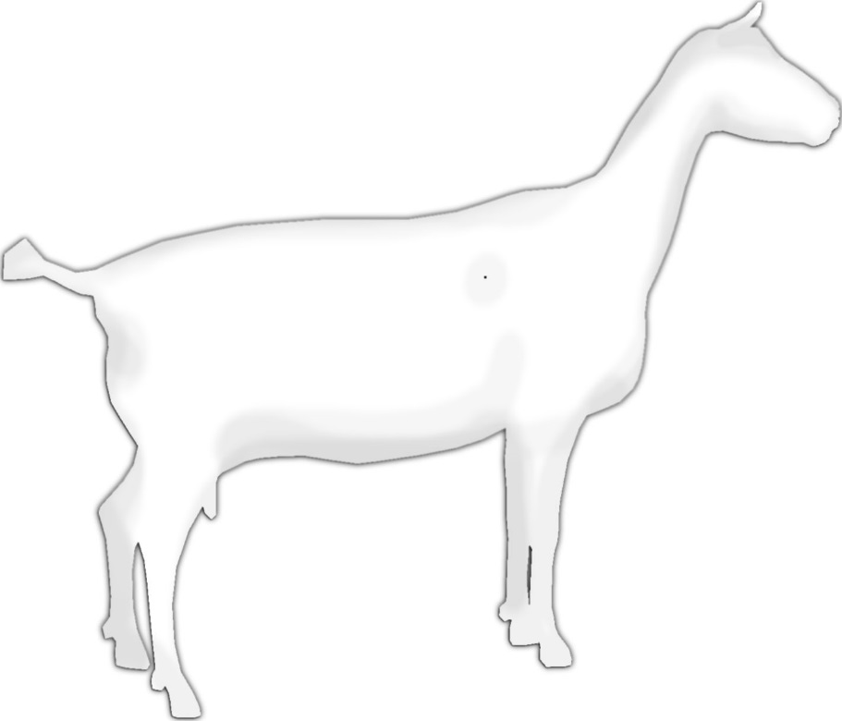

The Saanen dairy goat originated in Switzerland. It is medium to large in size with rugged bone and plenty of vigor. Does should be feminine and not coarse. Saanens are white or light cream in color, with white preferred. They have erect ears (pendulous ears accepted). Color is white or cream for does and the bucks must be white. Spots on the skin are not discriminated against. Small spots of color on the hair are allowable, but not desirable. The hair should be short and fine, although a fringe over the spine and thighs is often present. Ears should be erect and alertly carried, preferably pointing forward. The face should be straight or dished. A tendency toward a Roman nose is discriminated against.

**Disqualifications**: Large dark spot in hair (more than 1-1/2" in any direction), any color other than white in bucks, gopher or elf ears.

### Toggenburg

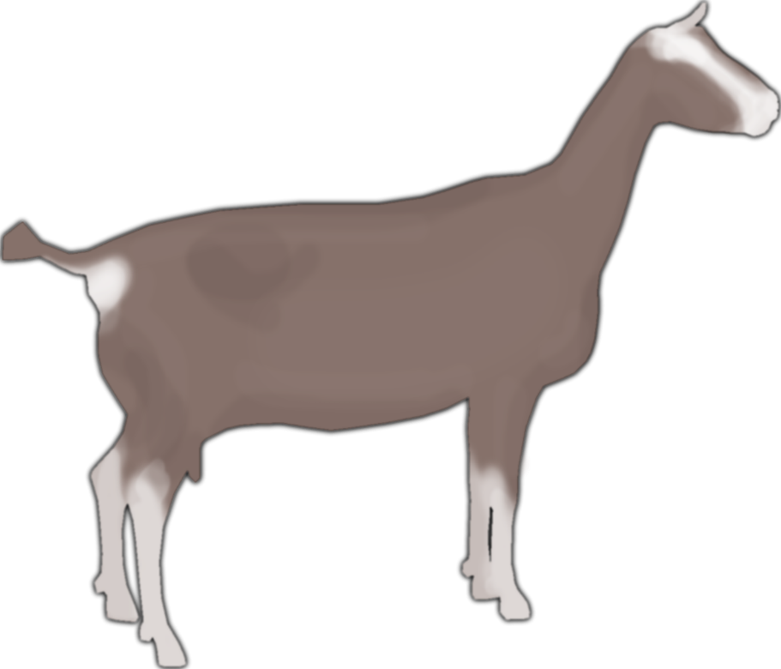

The Toggenburg is a Swiss dairy goat from the Toggenburg Valley of Switzerland. This breed is of medium size, sturdy, vigorous, and alert in appearance. The hair is short to long in length, soft and fine. Its color is solid, varying from light fawn to dark chocolate with no preference for any shade. Distinct white markings are as follows: white ears with dark spot in middle, two white stripes down the face from above each eye to the muzzle, hind legs white from hocks to hooves, forelegs white from knees downward with dark vertical stripe below knee acceptable; a white triangle on each side of the tail; white spot may be present at root of wattles or in that area if no wattles are present. Varying degrees of cream markings instead of pure white acceptable, but not desirable. The ears are erect and carried forward. Facial lines may be dished or straight, never Roman. Ears should be erect. Color must be a shade of fawn or brown with the following white or cream color markings (white preferred)- facial stripes, outline of ear, below knees and hocks and inside the top of the legs, and a triangle on each side of tail base. White spot may be present at the point of elbow and at root of wattles or where wattles would be if there are none. A dark vertical line may be present below the knees. Does which are black with Toggenburg markings, are permitted but will be identified with “Black” as a suffix to their registered name.

**Disqualifications**: Tricolor or piebald, black bucks, white stomach (except on British Toggenburg), large white spot in hair (more than 1-1/2" in any direction), pendulous, gopher, or elf ears.

### Nigerian Dwarf

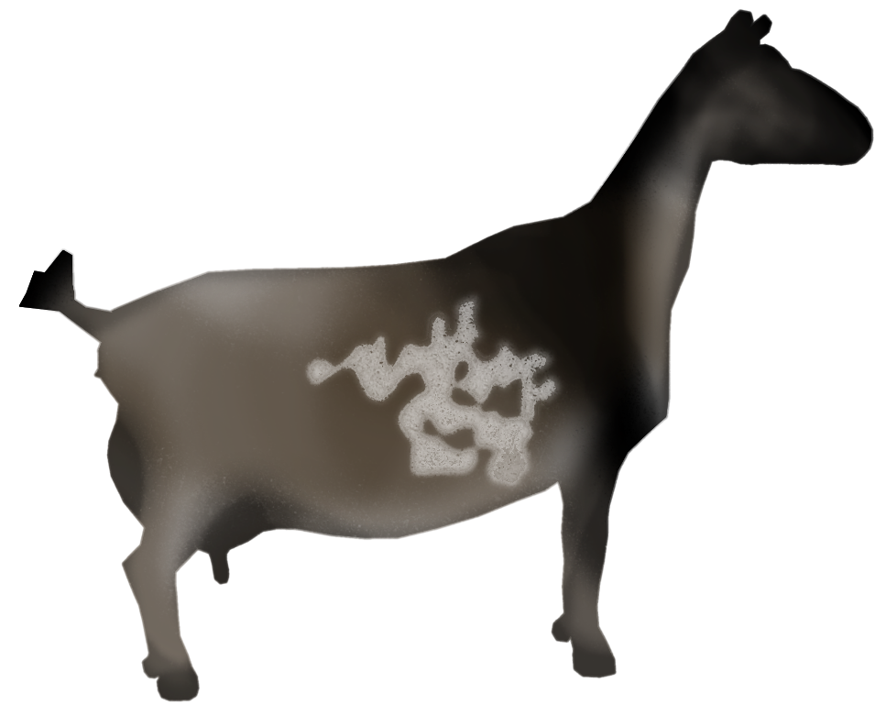

A miniature goat which must have erect ears and a straight face. Any color is allowed however, it is a serious fault to have “agouti” coloration (agouti defined as the intermingling of light and dark hairs.) It is also a very serious fault if the animals do not conform to the body measurement chart. This goat must have erect ears and a straight face.

24 months of age: male or female maximum height at withers: 22 inches (55.88 centimeters)

30 months of age: male maximum height at withers: 23 inches (58.42 centimeters)

30 months of age: female maximum height at withers: 22 inches (55.88 centimeters)

Note: Nigerian Dwarfs are of dairy type and are judged according to the dairy goat scorecard

**Disqualifications:** Convex or dished profile, polled (born naturally hornless), pendulous, gopher, or elf ears, over maximum height.

# “True Type” is the Standard

True Type doe and buck are the basis of comparison rather than the individual preference of the classifier. **Each animal is compared to the True Type per breed rather than comparing one animal to another (as in shows).** Classification and participating in shows are complementary programs, and breeders are encouraged to participate in both to more fully understand the strengths and areas of improvement in their animals.

###### Environment

While some consideration may be given for environment, the True Type is the standard which is used for comparison.

###### Allowance for Age

Animals must be compared to the True Type considering age and, for does, the number of lactation.

### Breed Standards



###### Animals not meeting breed standards will see their overall scores dropped by 5 points and are not eligible for Excellent scores.

# Breakdown of Traits

Shaded numbers represent the ideal range of scores. For example, for rump angle, 4, 5, and 6 are ideal.

### Rump (10% of final score)

* A well-sloped, wide and strongly anchored to back/vertebrae
* Impacts position of reproductive tract to be held high within abdominal cavity
* Improved fertility
* Better kidding ease & healthy recovery following kidding

###### Rump Angle (47% of rump score)

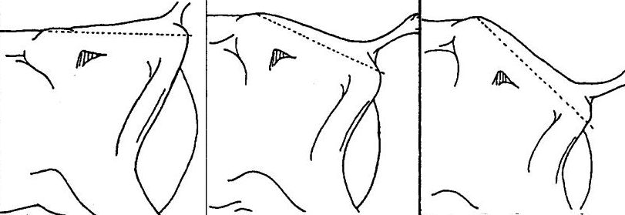This is the relationship of the pins with respect to the hook bones. Desired is when the angle is a 25 degree slope.

Level  Steep

###### Thurl Width (31% of rump score)

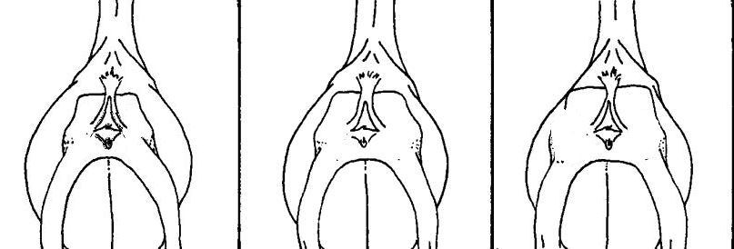The width of the rump of an animal is evaluated by standing at the rear. The measurement is taken from the middle point of the thurl to the middle point of thurl from the top of the rump.

Narrow  Wide

**Loin Strength (22% of rump score)**

The desired loin is described as being “broad, and slightly arched; vertebrae defined; attachment to hook bones high and wide.”

Therefore, loin strength in this evaluation is to measure the degree to which the vertebrae are defined and the slight arch to the loin and the height of attachment to the hook bones. The desired loin is broad, with vertebrae defined, level from ribs to rump.

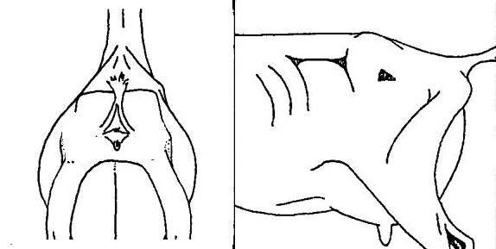  
Weak Strong

**Thurl Placement (Research)**

The thurls are high and wide apart, giving consideration to stage of lactation. When viewed from the side, the thurls should be located 2/3 of the way from the hip bones and 1/3 of the way from the pin bones.

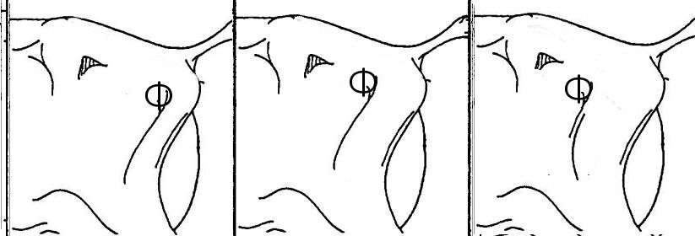

Back  Ahead

### Rump Defects

###### A-Shaped

The hook bones are lower than the vertebrae forming, an A-shape slope when hands are placed over the rump.

###### Short Rump

Refers to the distance between hooks and pin bone.

### Mammary System (42% of final score)

* Soft, high, wide and strongly attached, with good teat length and placement
* Healthy udders that are resistant to breakdown
* Easy to milk with effective milk letdown and milk-out
* Capacious udders for high milk volumes
* Ligament strength and udder attachment to keep udder free from contamination

###### Udder Depth (14% of mammary system score)

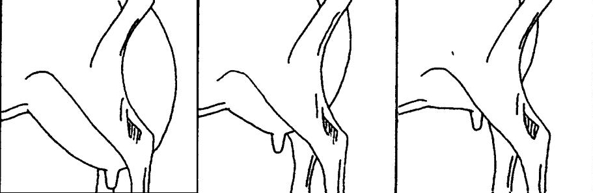

Deep  Shallow

The depth of udder is measured relative to the hocks, according to age. The mature goat’s udder is at least 5-7.5 cm (2-3 inches) above the point of the hock (desired 5). When the mature goat’s udder floor is well below the point of the hocks, it would be assessed as extremely deep (1). The udder floor of 1st fresheners should be well above these points.

###### Udder Texture (10% of mammary system score)

Defined as softness and freedom from excess tissue (meaty). Milked out udder illustrated. Fleshy udders which do not decrease in size when milked out or carry excessive flesh are to be discriminated against. The udder is soft, pliable, elastic and well collapsed after milking.

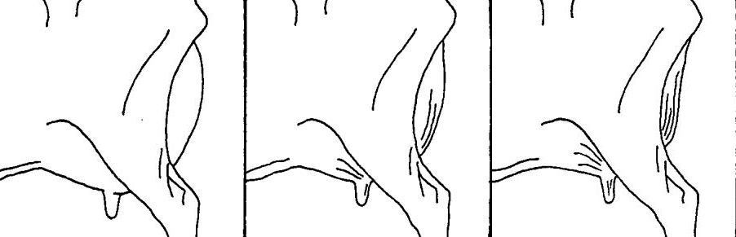

Fleshy  Soft

###### Medial Suspensory Ligament (20% of mammary system score)

Evaluated considering the depth of cleavage and evidence of division between halves of the udder. Also, evaluate the degree of stretch (prominence) of the ligament in center (top) of rear udder attachment.

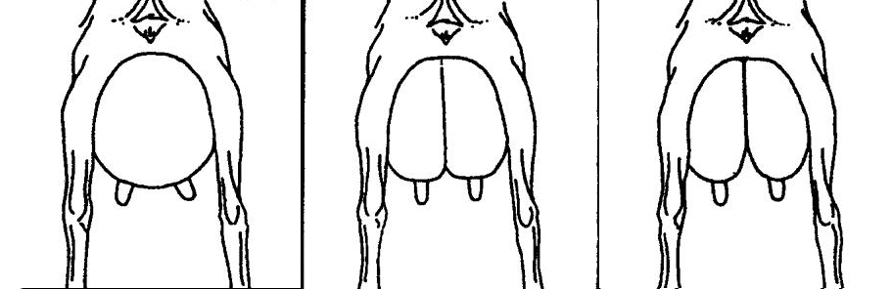

Weak Strong

###### Fore Attachment (20% of mammary system score)

Tightly attached, wide and long, blending smoothly into the body. Extending well forward onto the abdominal wall. This is the attachment of the udder to the body wall. Good width, well attached, extending from side to side. It should be noted that a doe with a bulgy fore udder does not necessarily have a weak fore attachment.

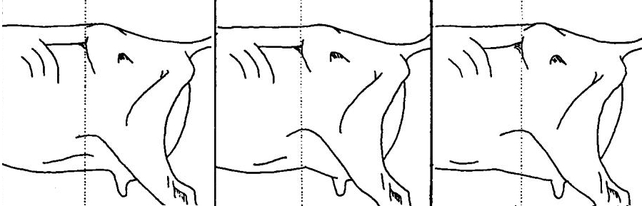

Weak  Strong

###### Rear Attachment Height (14% of the mammary system score)

This is the height of rear attachment. The stage of lactation and amount of milk in the rear udder must be taken into consideration in making this evaluation. The measurement is the distance between the base of the vulva and the top of the milk secreting tissue.

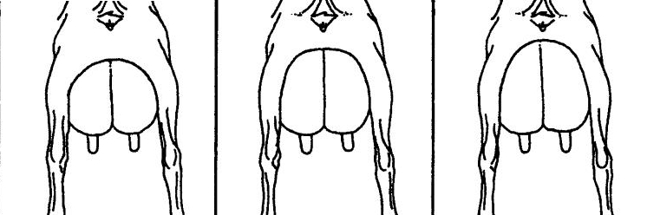

Low  High

###### Rear Attachment Width (12% of the mammary system score)

As well as being high, the rear attachment should be wide. The width of rear attachment is assessed as the width at the top of the milk secreting tissue.

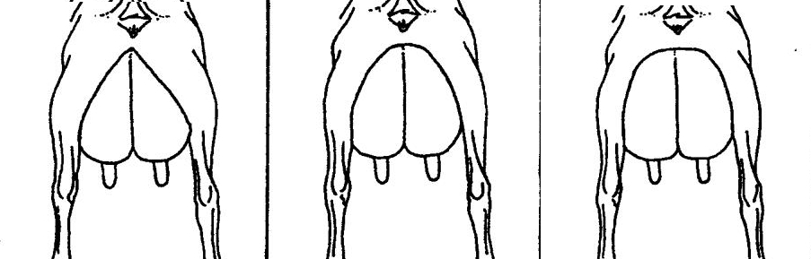

Narrow  Wide

###### Teat Placement (8% of mammary system score)

Teat placement is to be evaluated independently of the plumpness of the teats.

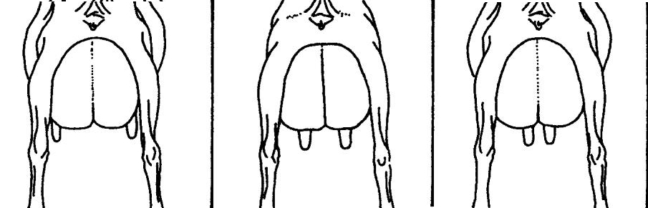

Wide  Close

###### Teat Length (2% of mammary system score)

Excessively large, long or small teats are discriminated against.

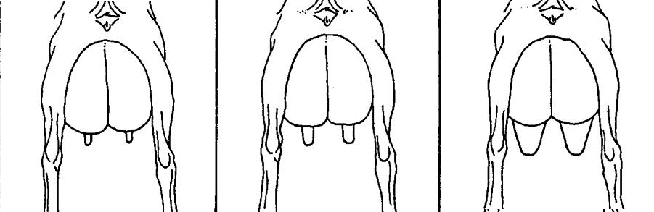

Small/short  Long/Large

### 

### Mammary System Defects:

###### Lacks udder shape

This condition refers to the lack of symmetrical shape, no indication of division between halves, the udder cannot be seen behind the doe’s leg when viewed from the side etc.

###### Bulgy Rear udder

Is when viewed from the side the rear udder protrudes well past the vulva

###### Twisted/Tilted udder

This refers to a twist in the udder from the attachment where the udder is turning towards the left or the right.

###### Unbalanced Half

The term “unbalanced” would be interpreted as being unbalanced between the two halves of the udder. If the udder is unbalanced without any apparent injury, it should be discriminated against and more so in younger animals since this may be an inherited trait.

Reclassification for goats with unbalanced udders: The classifier will ask whether the previous classification report is available. If so, they will check whether the udder was ticked “unbalanced”. If so, then he/she will probably not raise the final classification. If the udder was not ticked “unbalanced”, then he/she will give consideration to raising the animal. If the breeder does not have the classification slip, then the classifier will average both sides, whichever is unbalanced, and estimate an average.

###### Blind Half

Blind half is one which has never given milk.

###### 

###### Short Fore

Short refers to the length of fore udder. Care should be exercised in the use of the term “short” when referring to an animal which is nearly dry.

###### Shelved Fore udder

Refers to front of udder forming a shelf.

###### Abnormal teats

Webbed, spur, double teats, extra teats and double orifice would be considered as the same basic condition and would be called “Abnormal”.

### [Dairy Strength (20% of final score)](https://www.holstein.ca/PublicContent/PDFS/EN/Services/Classification_DairyStrength.pdf)

* Well-sprung, open ribs with adequate width
* Adequate capacity for the consumption of a high forage diet
* Sustains proper body condition with high milk output
* Healthier doe with room for vital organs to operate
* Symmetric, and balanced head indicating femininity/masculinity. Broad muzzle with full, correctly formed nostrils, jaws meeting correctly, strong lower jaw, and a broad forehead.

###### Stature (12% of Dairy Strength)

Stature refers to the height of the animal at the hip bones. Breed standards are used in evaluating the stature of animals. Animals that meet the breed standard receive a code 7-8, animals far exceeding breed standards will receive a 9 and animals extremely short code 1.



Height at Front End (3% of Dairy strength score)The animal is equal or slightly taller at the withers than at the hips.

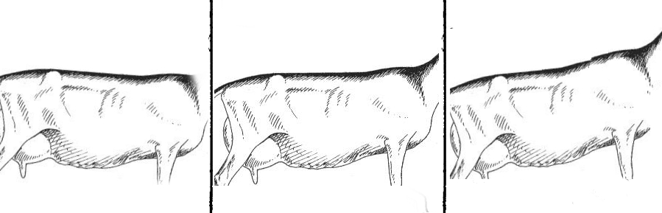

Low High

###### Chest Width (23% of dairy strength)

Width of chest (floor) is important in the breed. Care should be taken to note the width of the floor rather than the distance between the front legs.

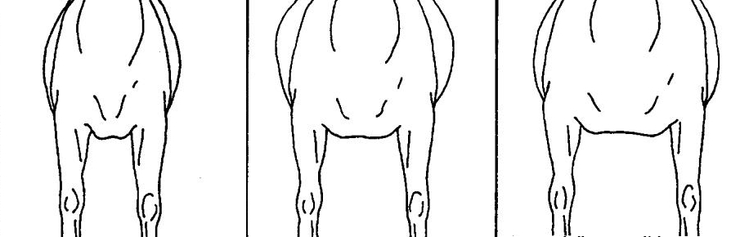

Narrow  Wide

###### Body Depth (17% of dairy strength)

Body depth refers to the depth of the animal’s body at the rear rib.

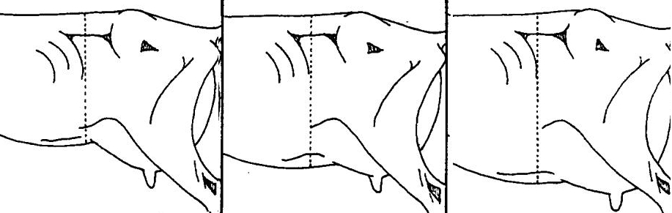

Shallow  deep

###### Angularity (28% of dairy strength score)

Dairy form is evaluated considering angularity, freedom from coarseness (head to tail), spring of rib and cleanness of thighs.

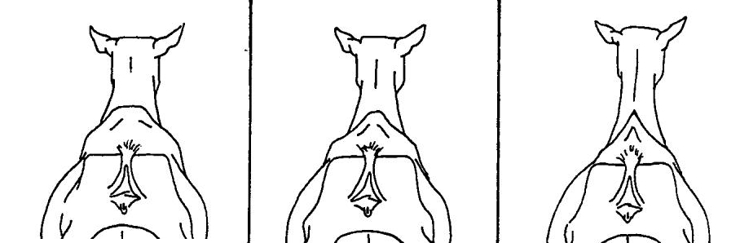

Coarse  Angular

###### Body Condition Score (5% of dairy strength score)

Animals who grade less than 2.0 are in need of immediate medical intervention as they are at great risk of chilling and dying quickly. Likewise, animals that are a 5.0 risk of metabolic problems due to being so obese. A doe should be in the 2.25 to a 3.5 range at dry off. She should be about a 2.75 to a 3.5 at kidding. And, she needs to be at least a 2.0 or more at 45 days into lactation. This is the bare minimum and really she needs to be closer to 3.0 in order to maintain proper condition through a 305 day lactation. A buck should be at least a 3.0 at the beginning of rut in order to carry any condition at all throughout the breeding season.

### Dairy Strength Defects

###### Wry face/Malformed Jaw

Discriminated against in accordance with the severity of the condition; usually dropped about one class in final class.

###### Undesirable Heads

Refers to miscellaneous conditions of the head which indicates the need for discrimination such as: narrowness, coarseness, short, abnormal jaw, lacking breed character, etc.

###### Weak Chine

This is the middle of the back where the loin and chine join. The ideal is to be level along the loin and chine area.

###### Weak crops

The crops are to be considered as the part of the animal behind the shoulder just below the chine.

###### Not well sprung

This refers to spring of rib. An animal not well sprung in the rear rib may also not be well sprung in the fore rib. In that case, the animal would be ticked as being narrow heart and narrow chest.

###### Lacks balance

The stylish animal has alertness, style, and walks well. Classifiers should avoid placing too much emphasis on the udder for style. Only animals which lack a great deal of style will be double ticked.

### [Feet & Legs (28% of final score)](https://www.holstein.ca/PublicContent/PDFS/EN/Services/Classification_FeetLegs.pdf)

* Widely placed legs, intermediate curvature, and a steep foot with a deep heel
* Greater resistance to lameness and foot diseases
* Straight-tracking locomotion with ample freedom of movement
* Mobility to get to the feed bunk, milk parlour, and for heat detection
* Clean and strong boned, with shape and movement of feet and legs resulting in proper carriage of the animal
* FEET: Well shaped, with deep heel, toes slightly spaced
* LEGS: pasterns strong, of medium length, and flexible, fore legs straight and wide apart, with feet squarely placed. Hind legs nearly perpendicular from hock to pastern from the side view, straight and wide, apart from the rear view. Hocks have clearly molded bone, flat and strong, with tendons well defined

###### Pastern strength (20% of Feet and Legs score)

Pasterns should be strong and flexible.

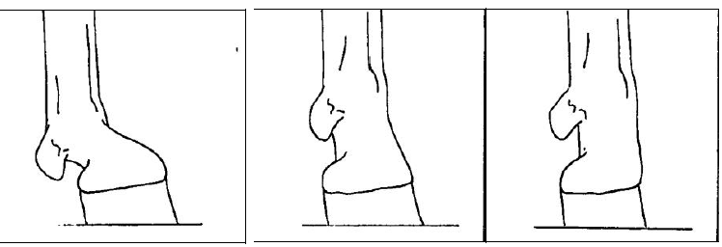

Low  Steep

###### 

###### Heel Depth (20% of Feet and Legs score)

A deep heel is the most desirable. Consistency throughout the components of the foot, including: claw size, heel depth, and width of sole (proportionate to the size of the animal).

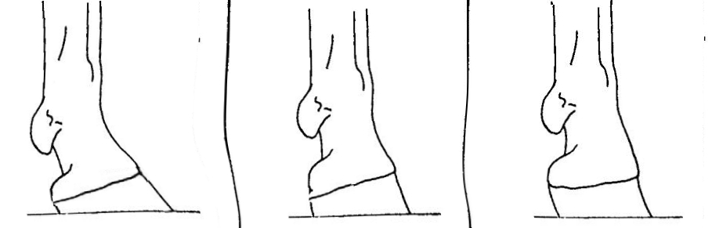

Shallow Deep

###### Bone Quality (12% of dairy strength)

Should be interpreted as flatness of bone in leg, ankle to stifle, including the hock.

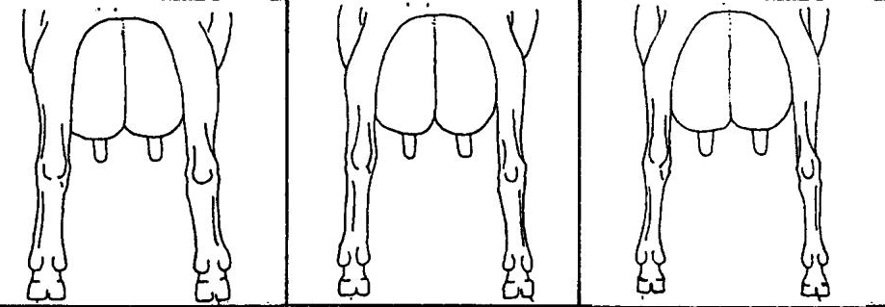

Coarse/ round  Flat/fine

###### Rear Legs-Side View (17% of feet and legs)

The set of the rear legs is to be evaluated as intermediate (5), desired (9), extremely sickle; (1), extremely posty. This determination is made, by standing at the side of the animal and determining the curvature of the rear leg. An overall picture of the curvature of the rear leg from the stifle to the ankle (side view) should be used in making this determination. The condition of an animal being straight on the rear legs is discriminated against as much as an animal being sickled on the rear legs.

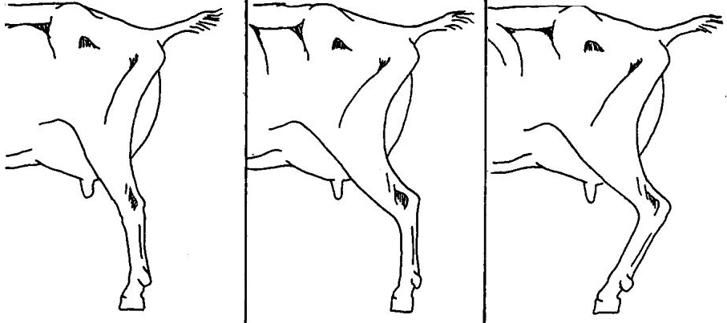

Straight  Sickled

###### Rear Legs-Rear View (31% of feet and legs)

When viewed from behind, the rear legs are widely set, parallel with each other. When on the move, there is ample space between the hocks.



Hocked in  Wide

Feet and Legs defects

###### Weak pasterns

This condition refers to a lack of strength where the pastern joins the ankle. A springy pastern is not necessarily a weak pastern. Care should be taken in evaluating this characteristic giving due regard to housing conditions.

###### Swollen joints

Swollen joints are an inherited rheumatic condition and should be penalized. Goats with severe swollen joints will not be classified higher than “Good Plus” on overall score and not higher than “Good” on feet and legs.

###### Toes out front

All animals appear to walk with a slight amount of toeing out. Tick only when pronounced.

###### Open toed

This condition will not be ticked unless serious.

###### Bowed rear legs

This section refers to rear legs being bowed at the pasterns when animal is standing. The leg tends to curve inward instead of being straight.

###### Bowed front legs

This section refers to front legs being bowed at the knee when animal is standing. The leg tends to curve forward instead of being straight.

### Genitalia (Males only)

Genitalia are relatively large, symmetric and balanced. Free from abnormal and extra teats. It has a strongly attached scrotum without excess division. Firm, even testes.

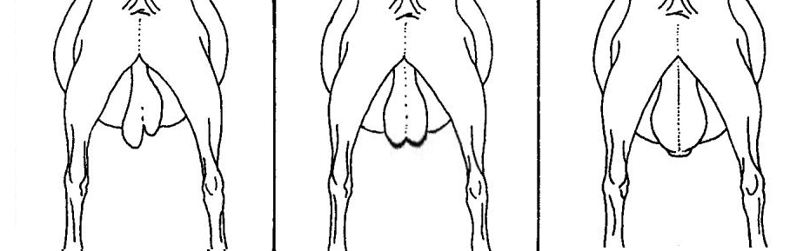

Abnormal  Desirable

